**Section 1**

Q1.Shell program to find greatest number from given three number

Code :

#!/bin/bash

read -p "enter first number : " num1

read -p "enter second number : " num2

read -p "enter third number : " num3

if [ $num1 -gt $num2 ] && [ $num1 -gt $num3 ]

then

echo "$num1 is the greatest number"

elif [ $num2 -gt $num1 ] && [ $num2 -gt $num3 ]

then

echo "$num2 is the greatest number"

else

echo "$num3 is the greatest number"

fi

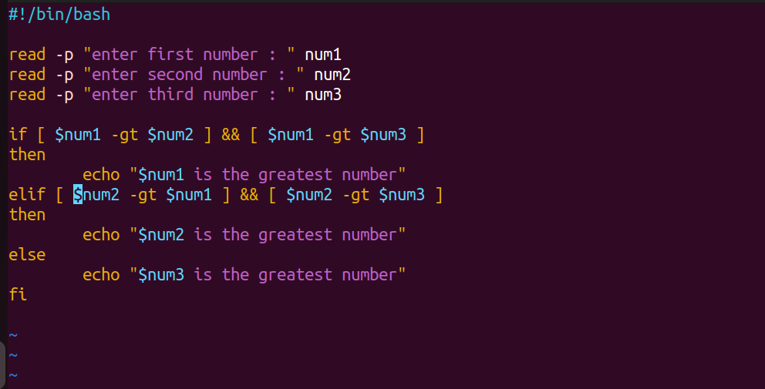

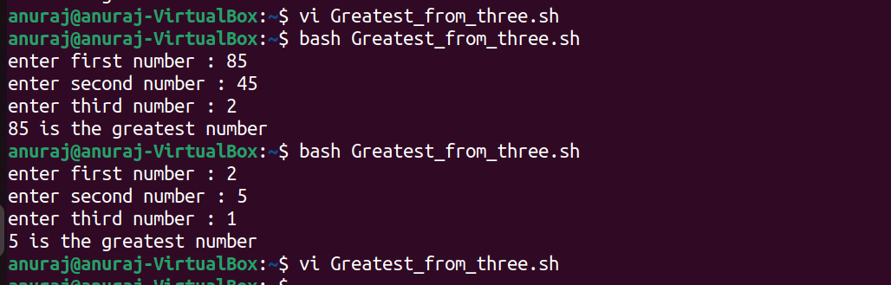

Q2 . Menu driven program for file management

Code :

#!/bin/bash

echo "File manager "

echo "Press 1 for view files in current directory"

echo "Press 2 to create new directory"

echo "Press 3 delete file in current directory"

read -p "Enter your choice : " ch

case $ch in

1)

ls

;;

2)

read -p "Enter directory name you want to create : " dir

mkdir ${dir}

echo "${dir} is succesfully created"

;;

3)

read -p "enter name of directory you want to delete : " dir

if [ ! -d ${dir} ]; then

echo "${dir} is not present"

else

rm -r ${dir}

echo "${dir} directory successfully deleted"

fi

;;

*)

echo "Invalid input"

esac

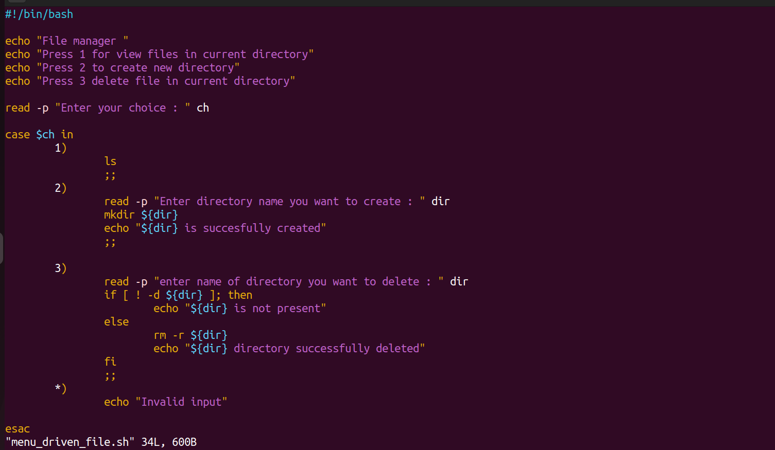

1)First menu operation show files in directory

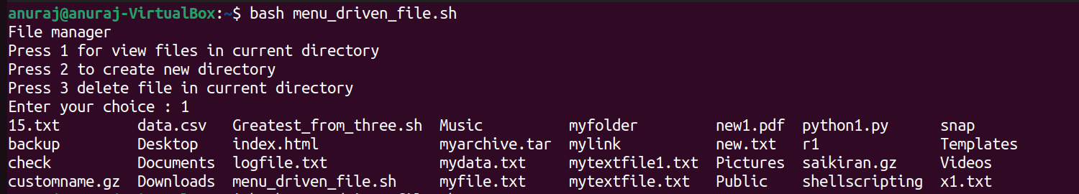

2) Second menu used to create directory

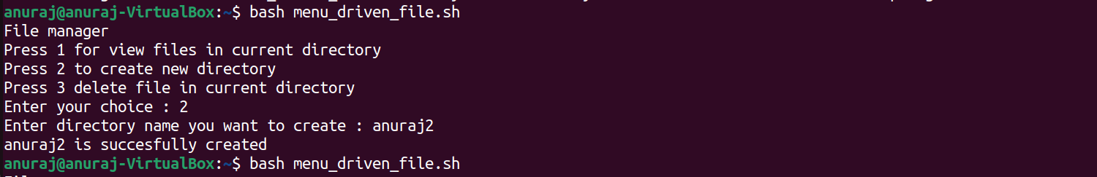

3)Third menu used to delete directory

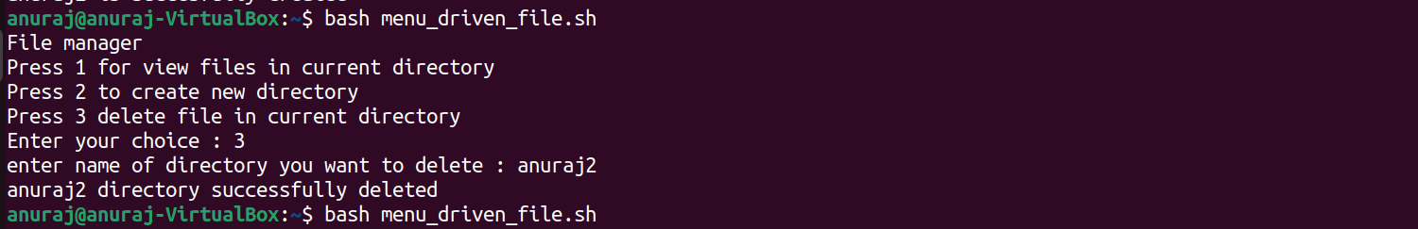

4) Exception case for directory name

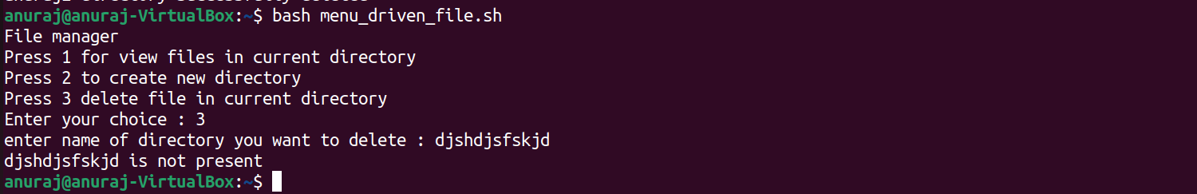

5) Exception case for case statement

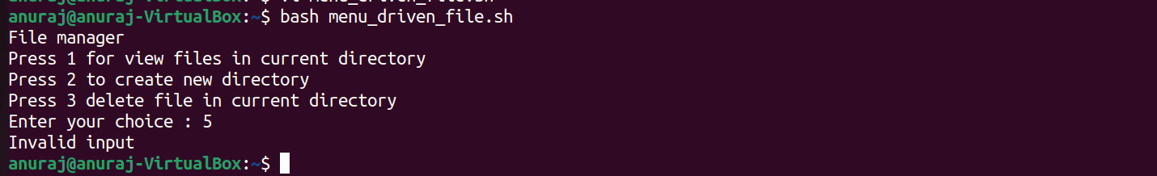

Q3.Directory operation

1. Create directory name dbda

Code : mkdir dbda

cd dbda

1. Create file name sep.txt

Code : touch Sep.txt

1. Rename thet file with name Batch2.txt

Code : mv Sep.txt Batch2.txt

1. Move file to another directory dbda_B2

Code : mkdir dbda_B2

mv Batch2.txt dbda_B2

ScreenShots for all operations

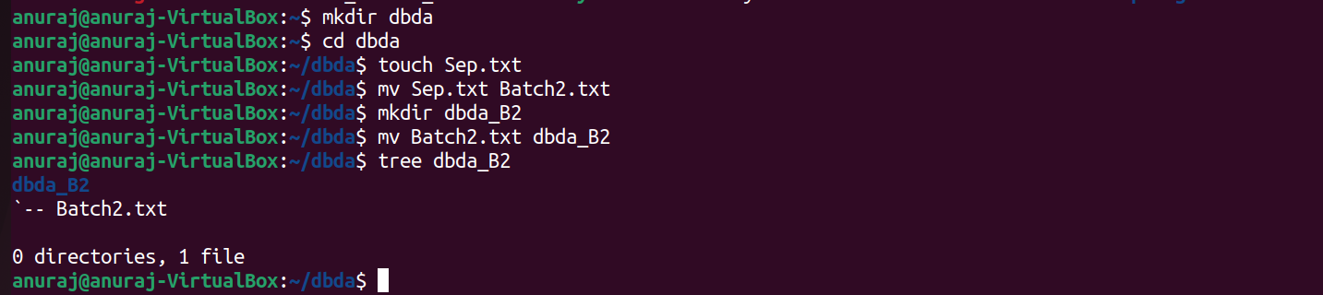

**Section 2**

Q.4 EC2 instance creation

Steps :

1) Open EC2 dashboard :

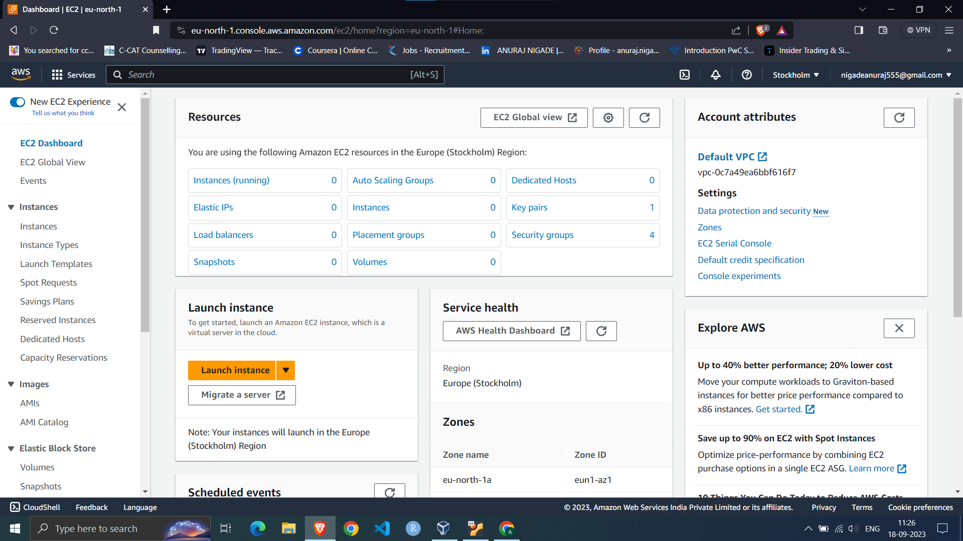

2) Click on Launch instance :

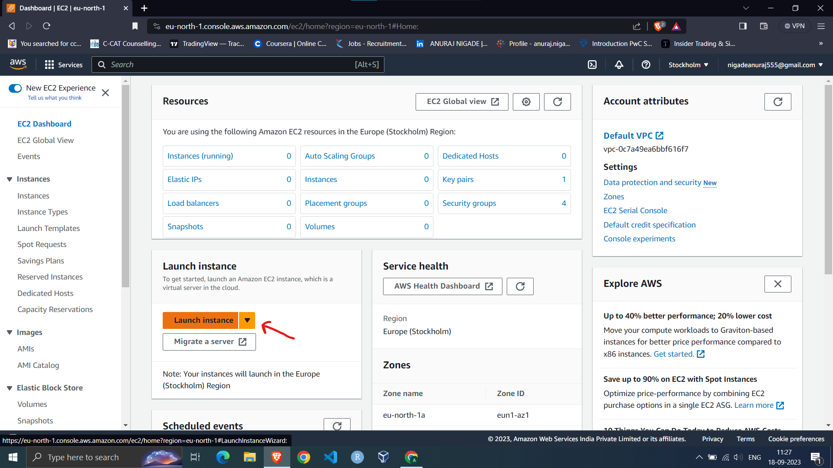

3) Give name to your instance

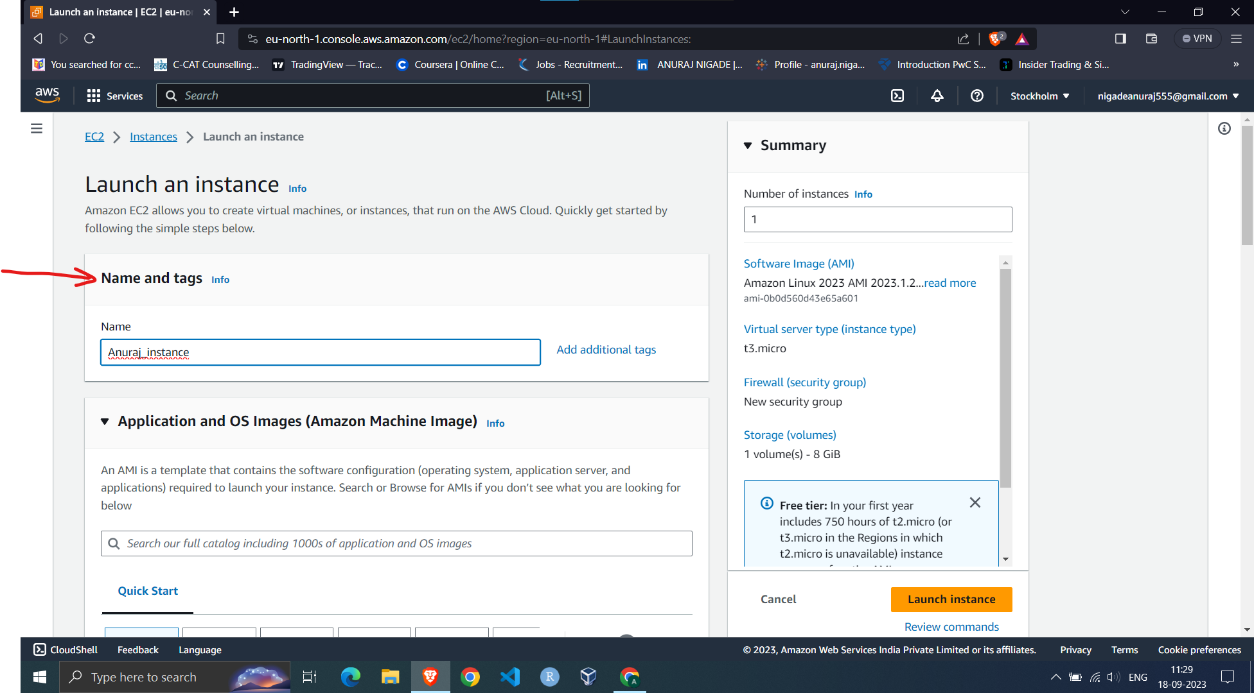

4) Select OS for your instance

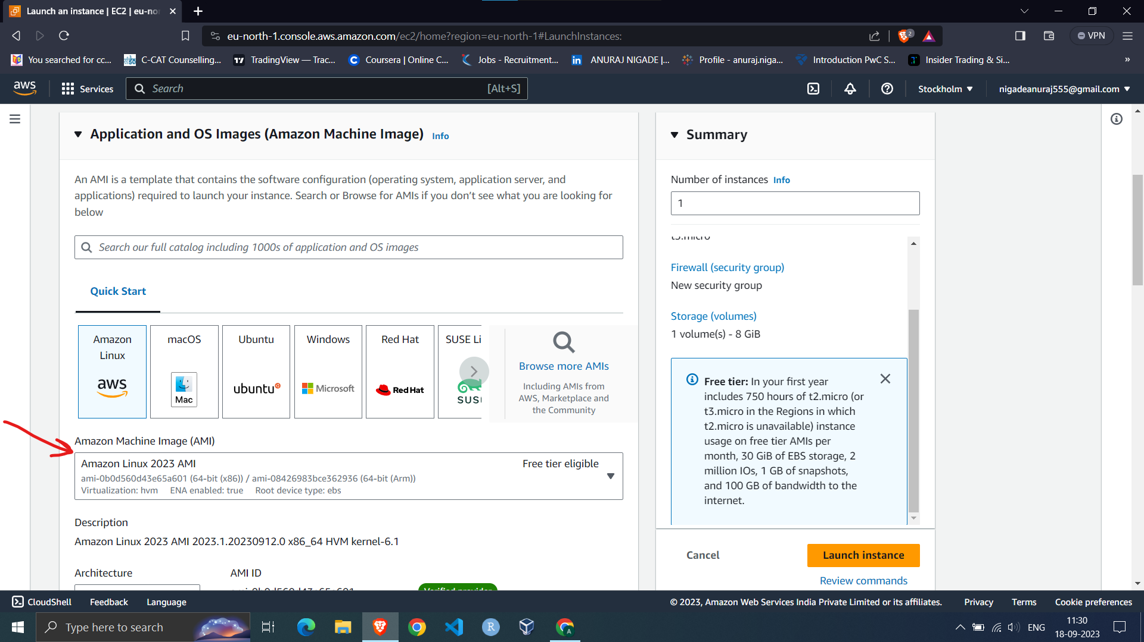

5) Select type of instance you want for your OS

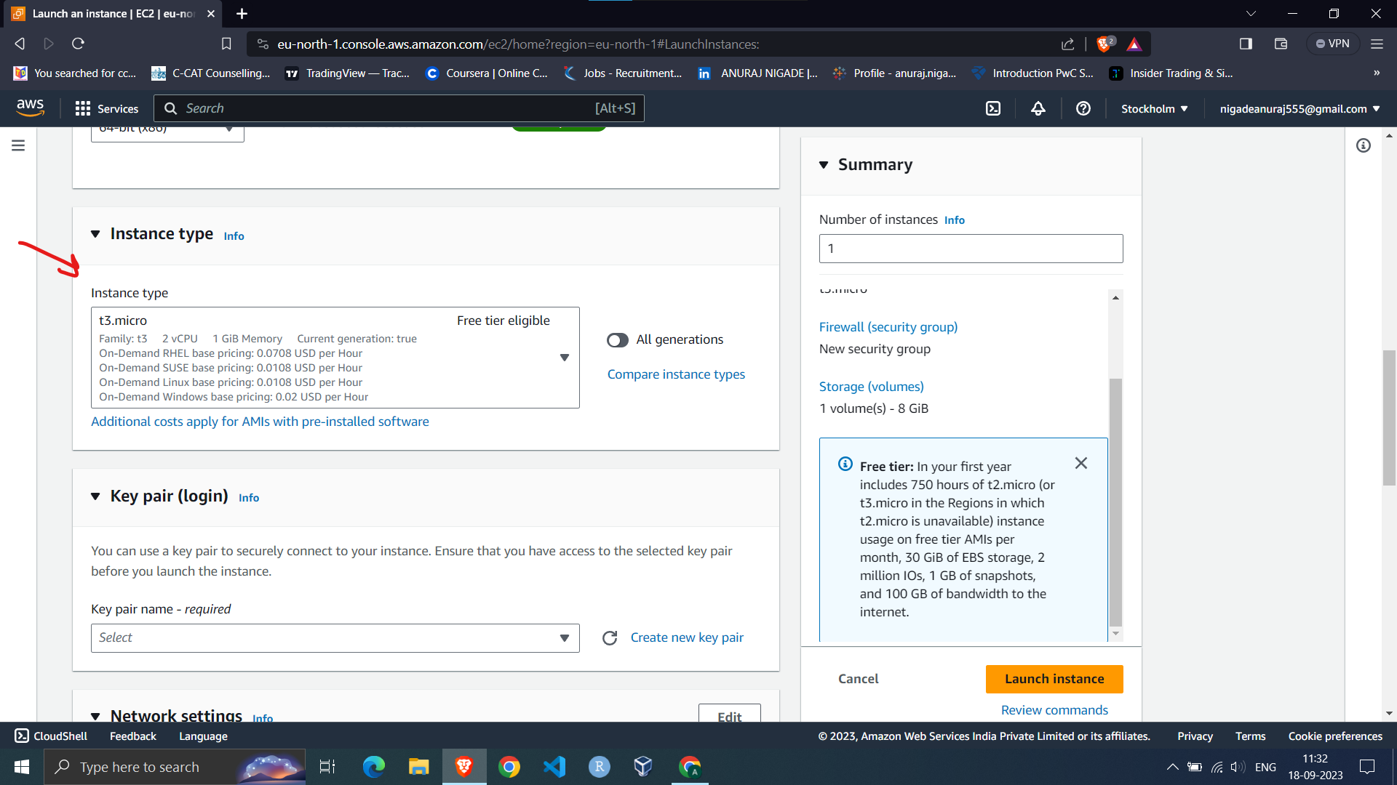

6) Select key pair login for your EC2 instance

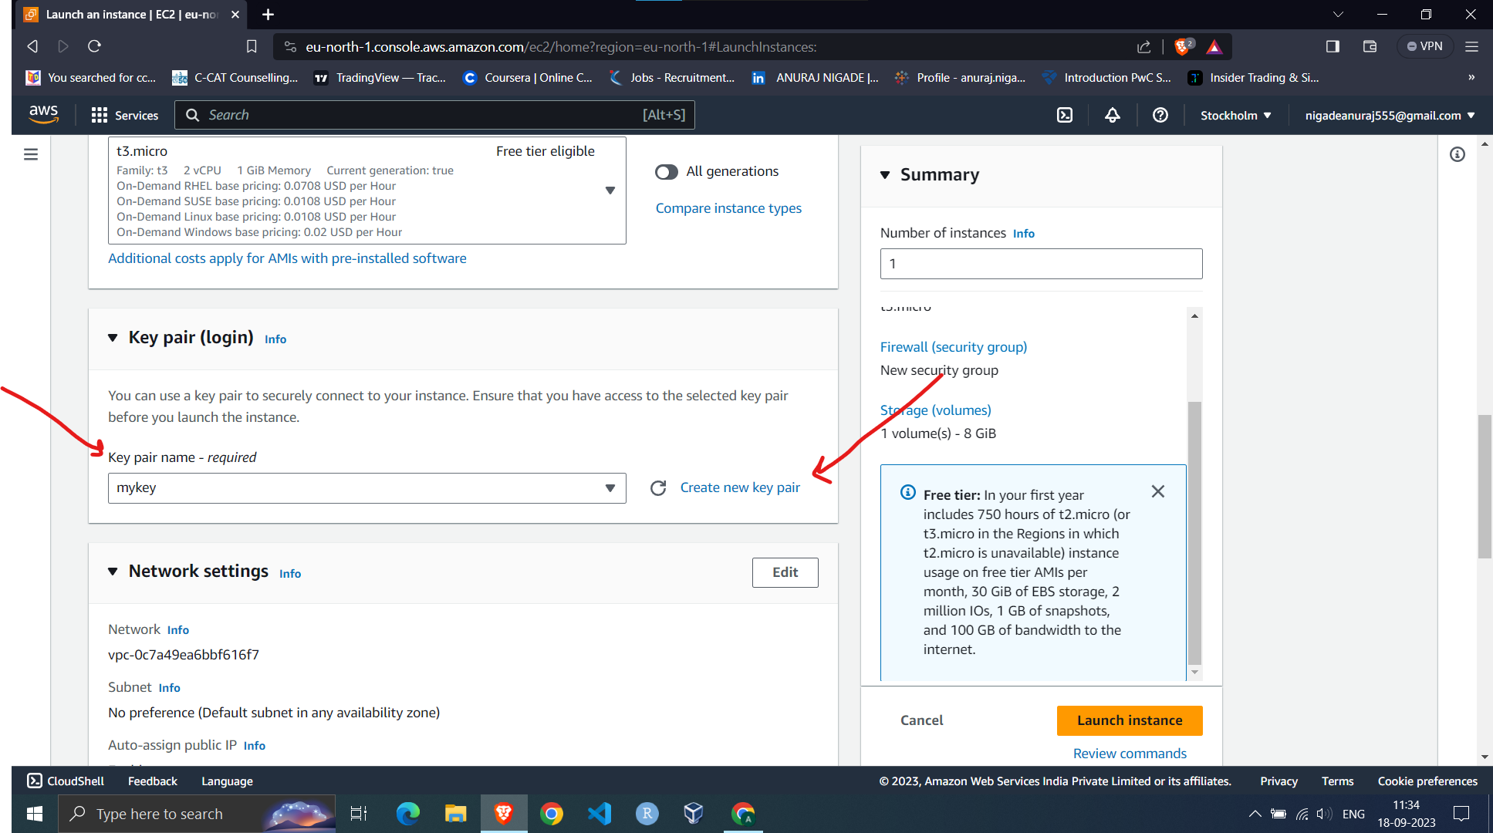

If you don't have key pair you can create it on clicking on Create new key pair as mention above.

7) In network setting option click on all check boxes

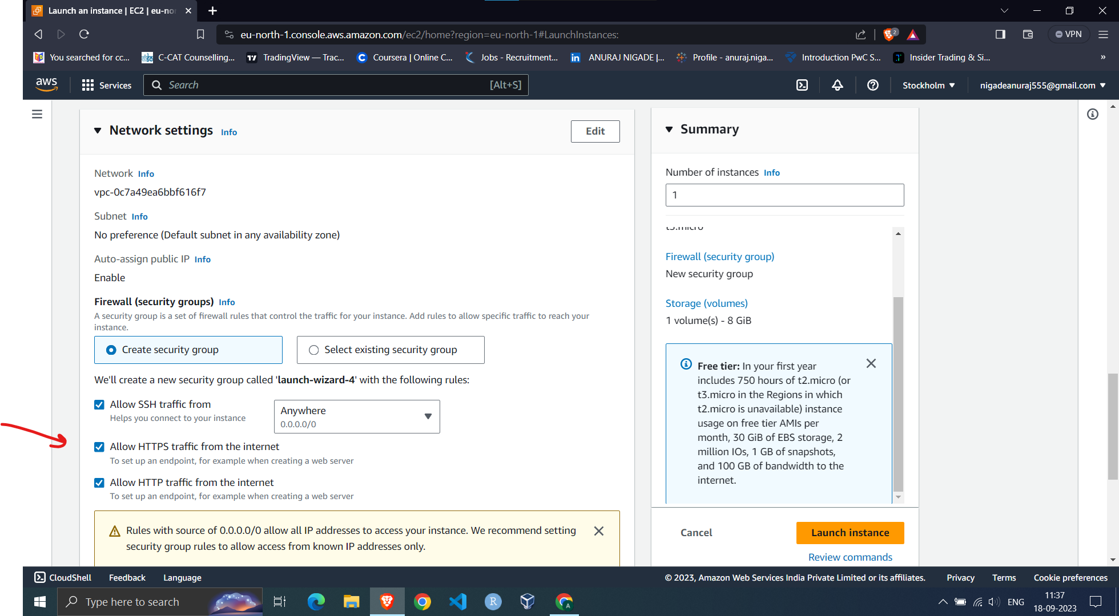

8) In configure storage define storage you want for your system

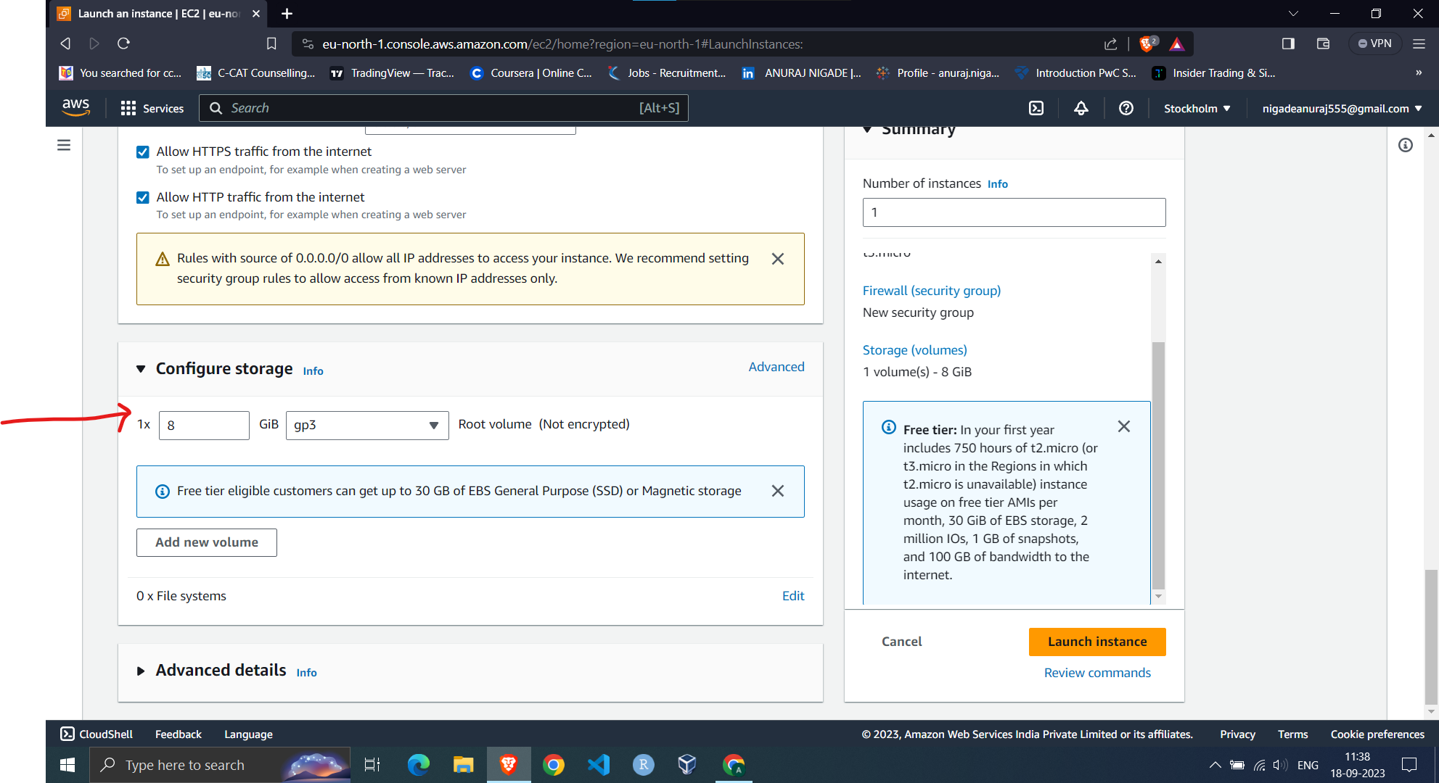

9) Click on launch instance to launch that instance

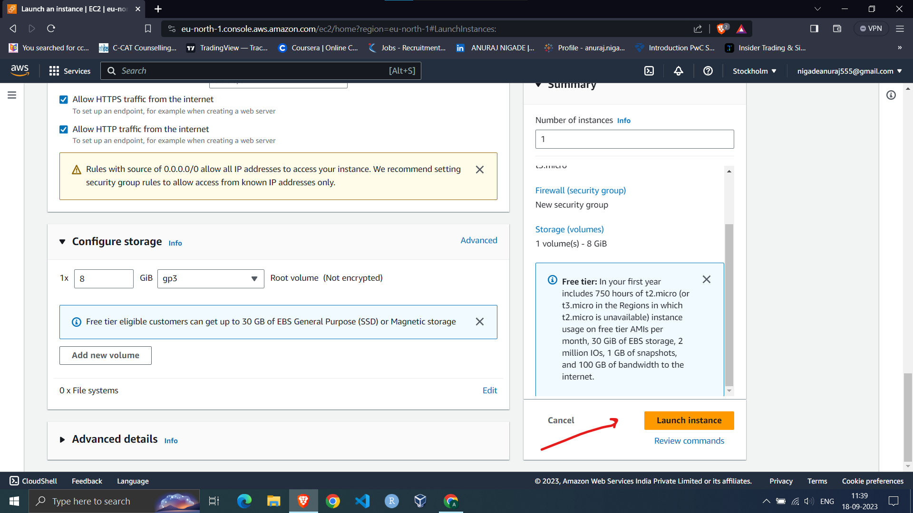

10) After that open putty and paste IP address of your instance in host name box

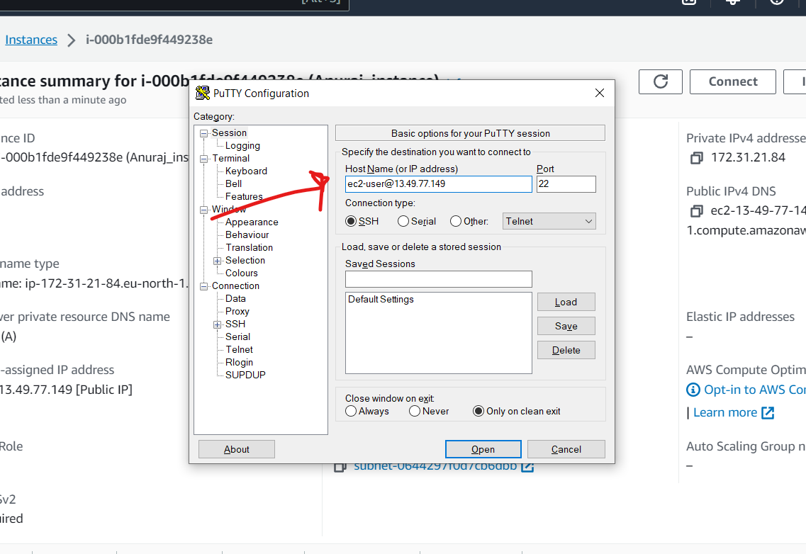

11) click on SSH

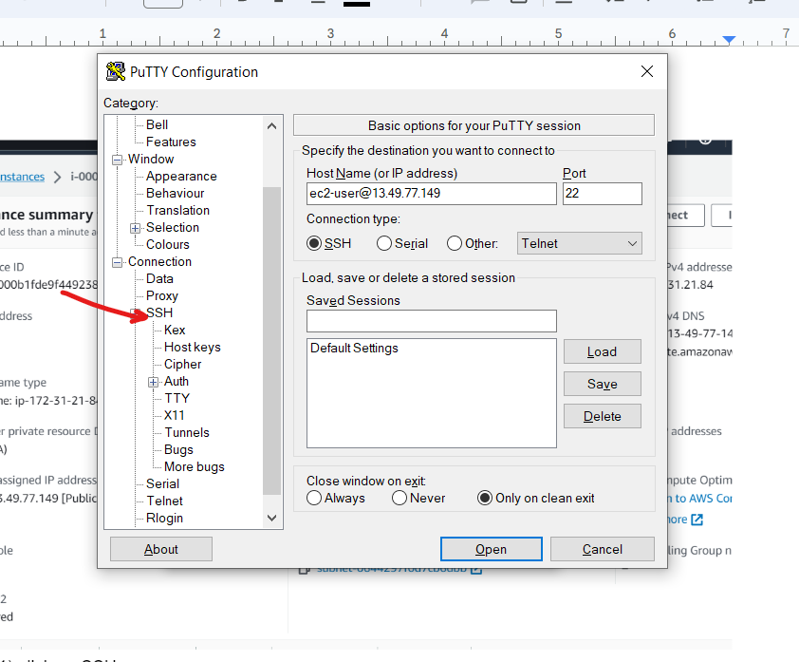

12) click on Auth in that credentials

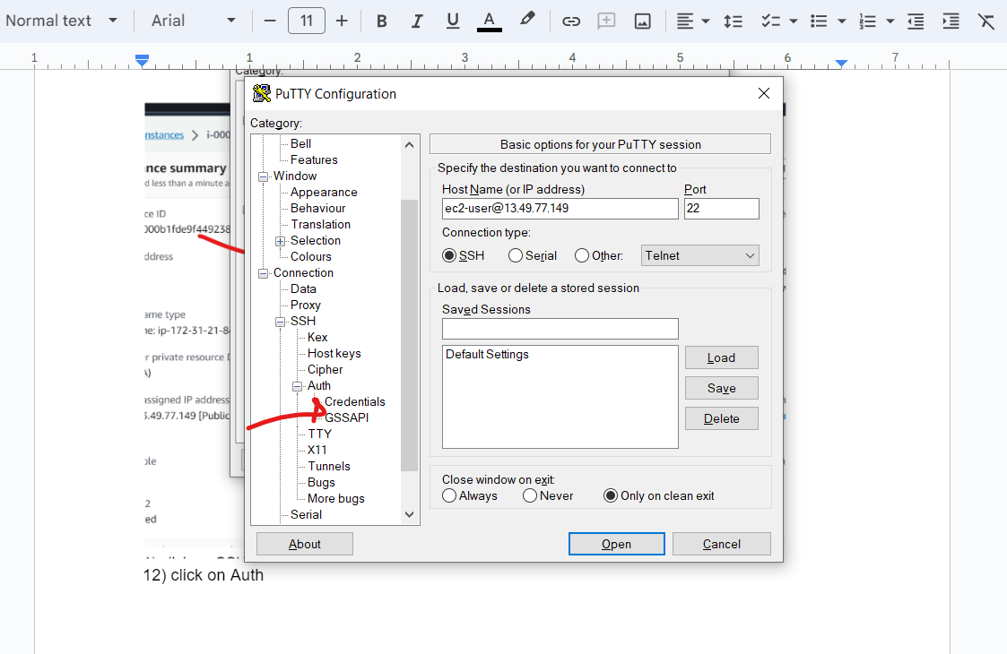

13) upload your key their and open

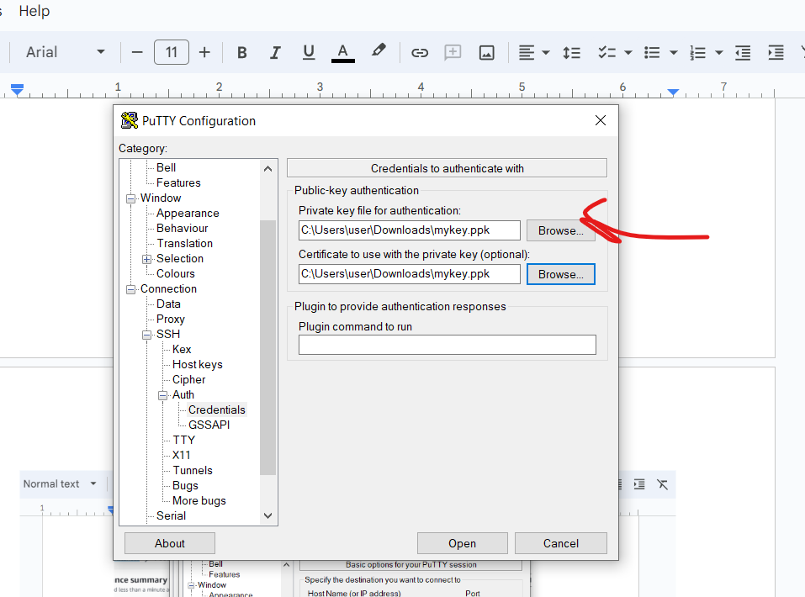

14) Now update instance using yum update -y

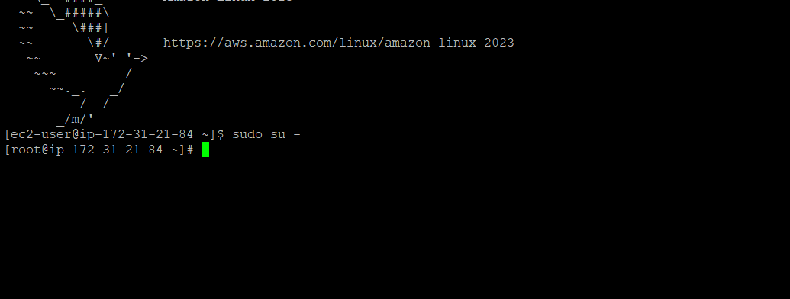

15) Install httpd server

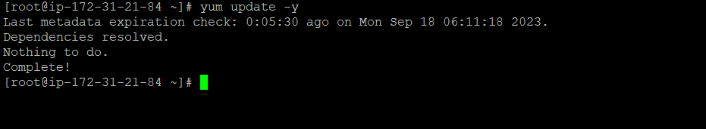

16) start that httpd server

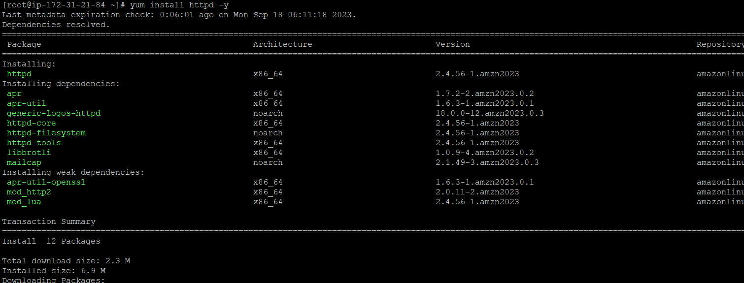

17) start httpd server



18) check status of that httpd server

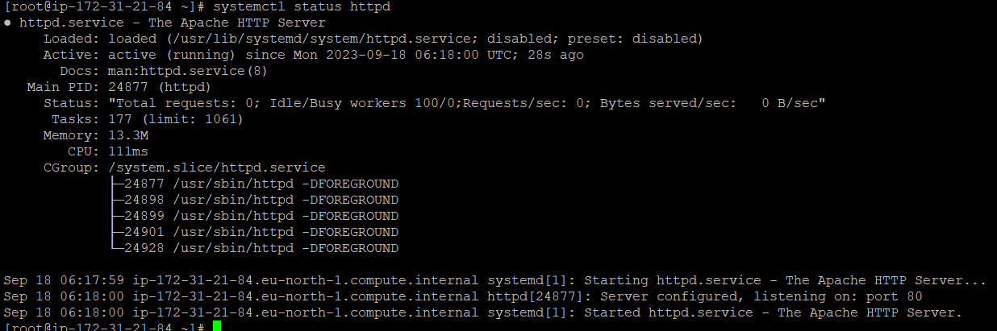

19) enable server to boot automatically at time instance launch



20)go to html directory



21)create index.html file



22) Paste IP address on new browser window to check web page you created

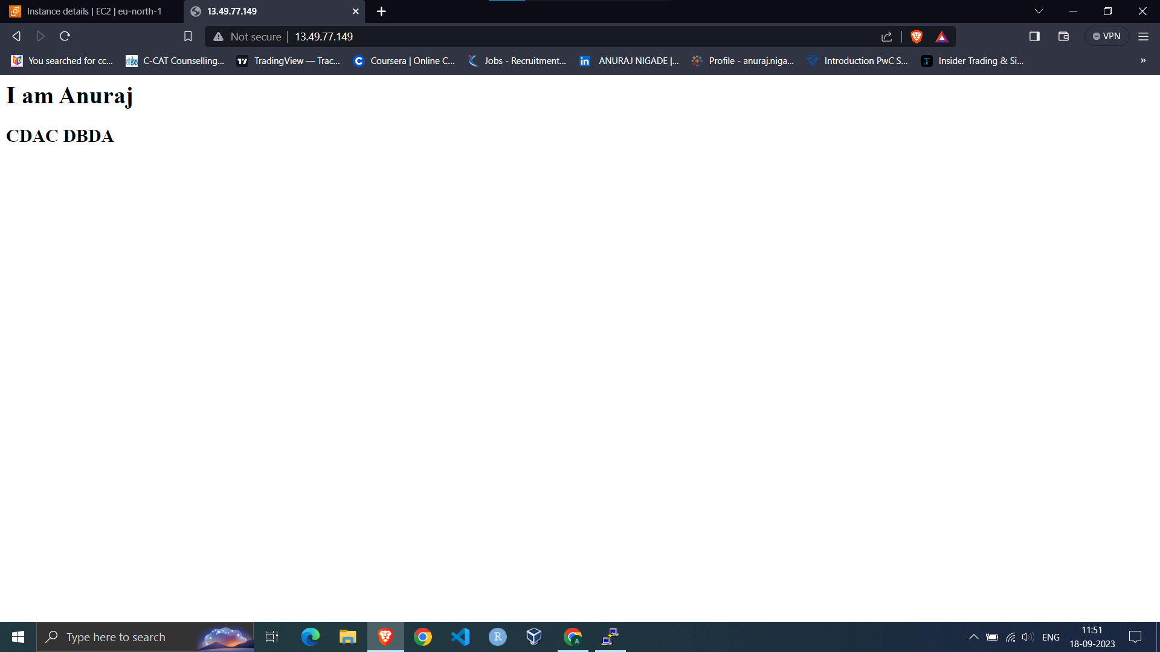

Q5.IAM user creation

Steps :

1)After login in IAM console click on user and in that Create User

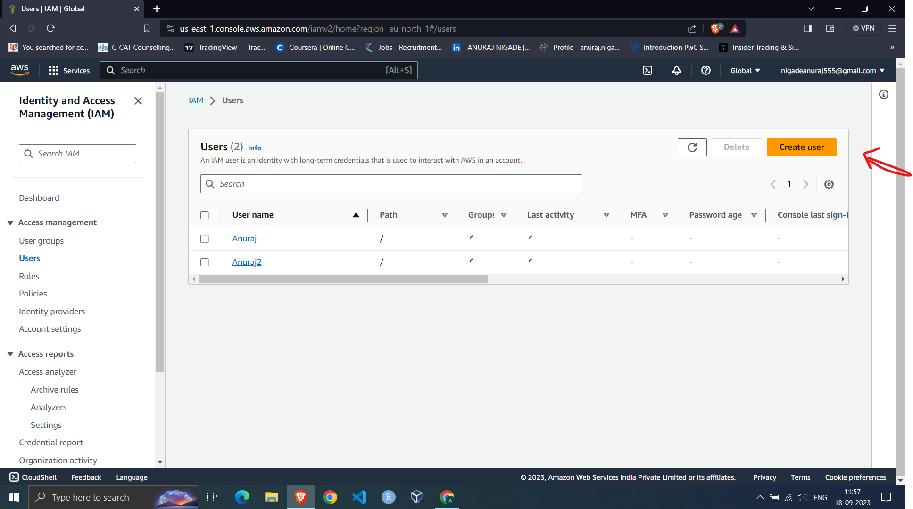

2) In user detail give username and click on next

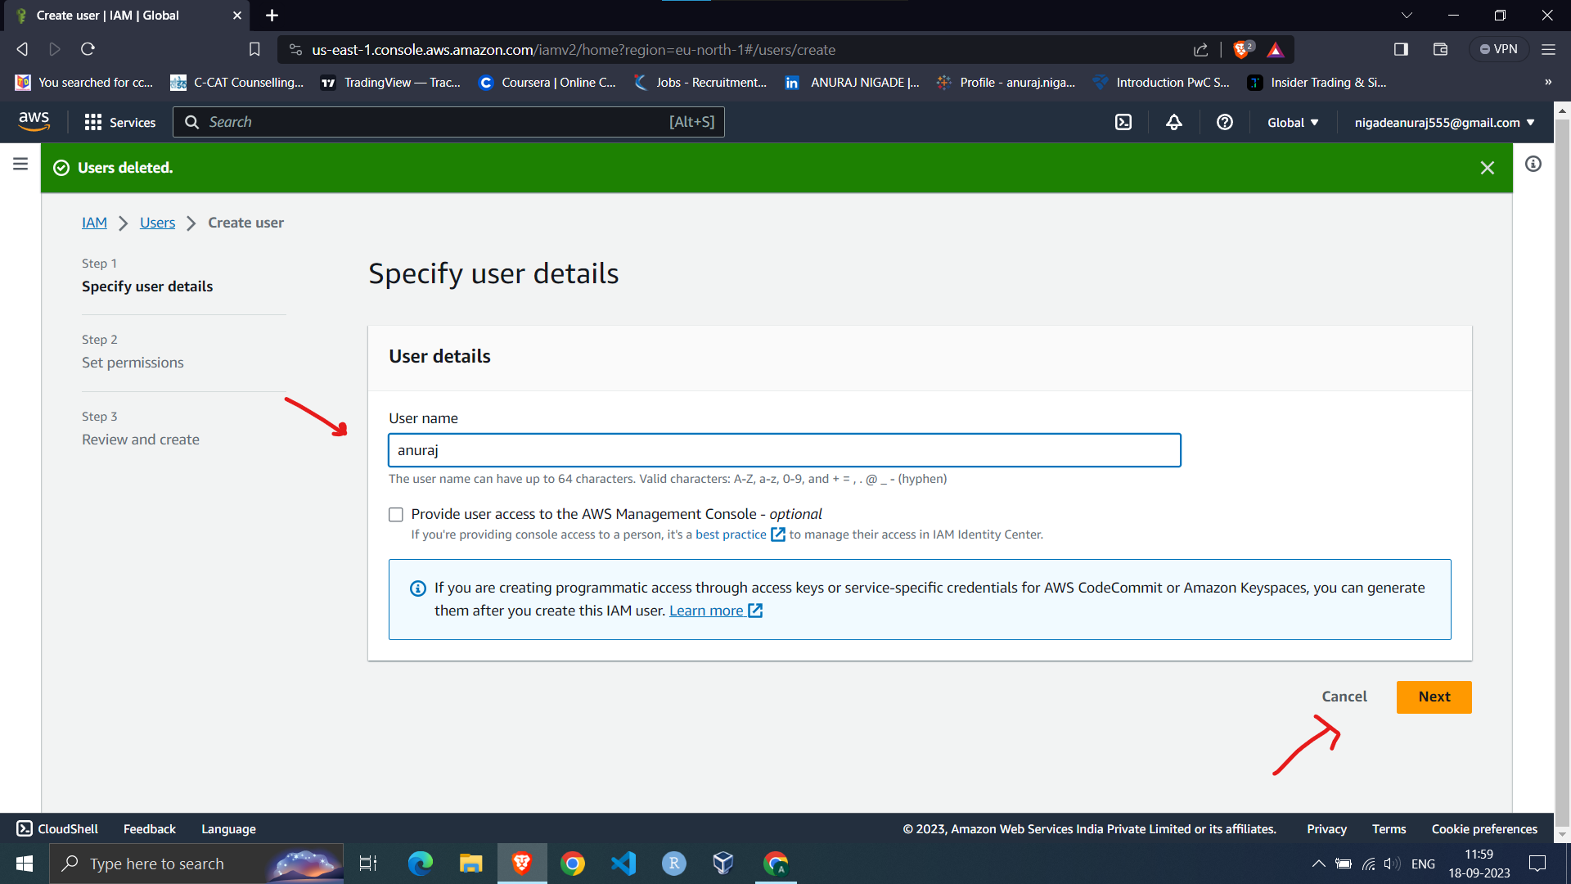

3) In permissions option click on attach policies directly

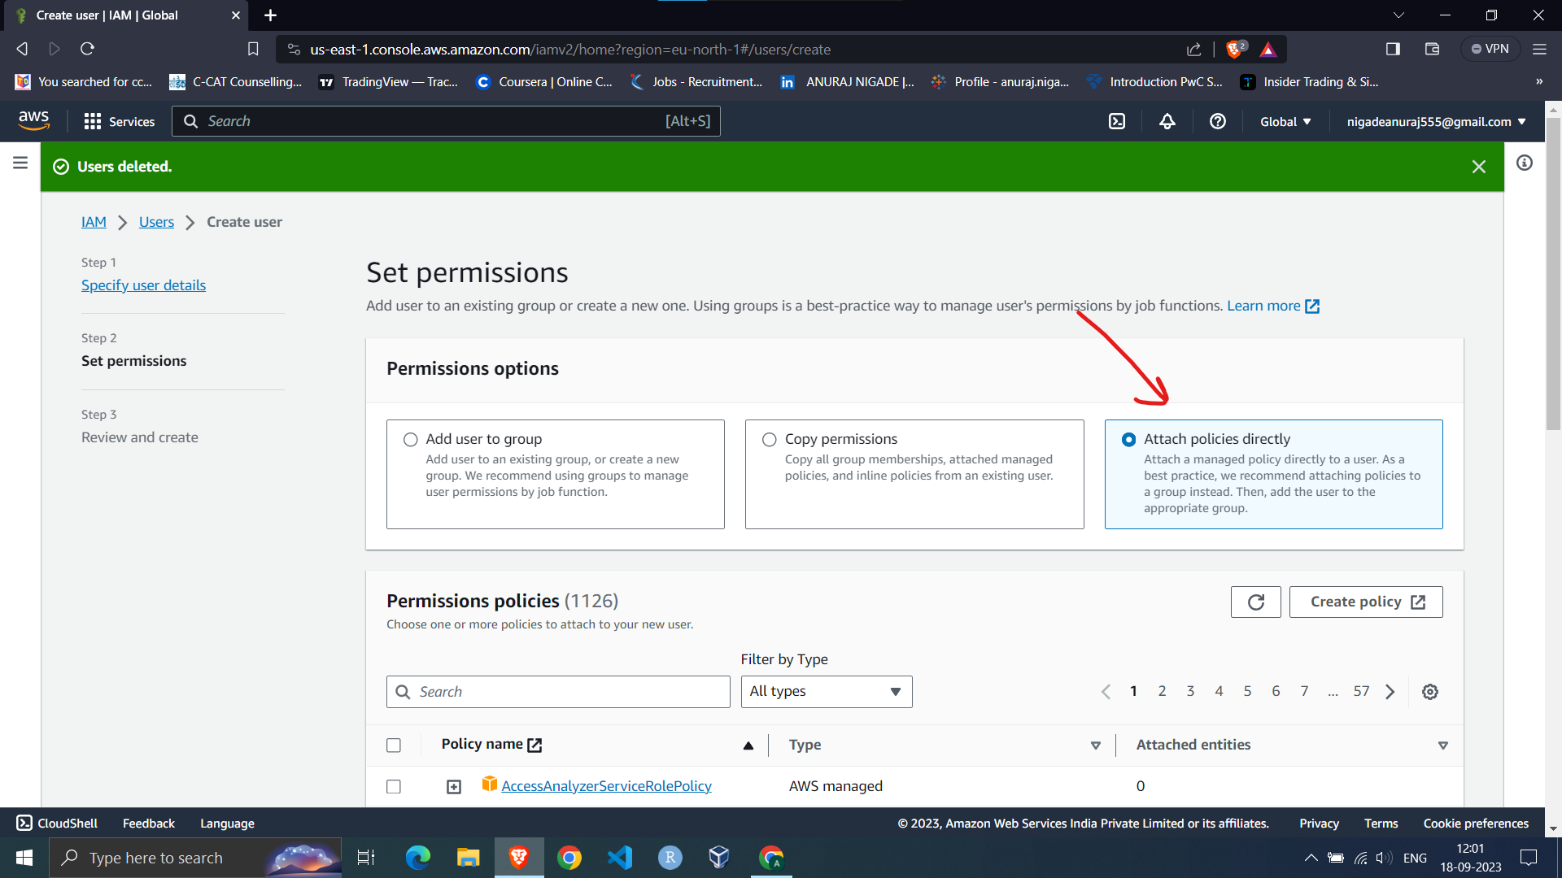

4) In that search S3 and click on AmazonS3ReadOnlyAccess and click on next

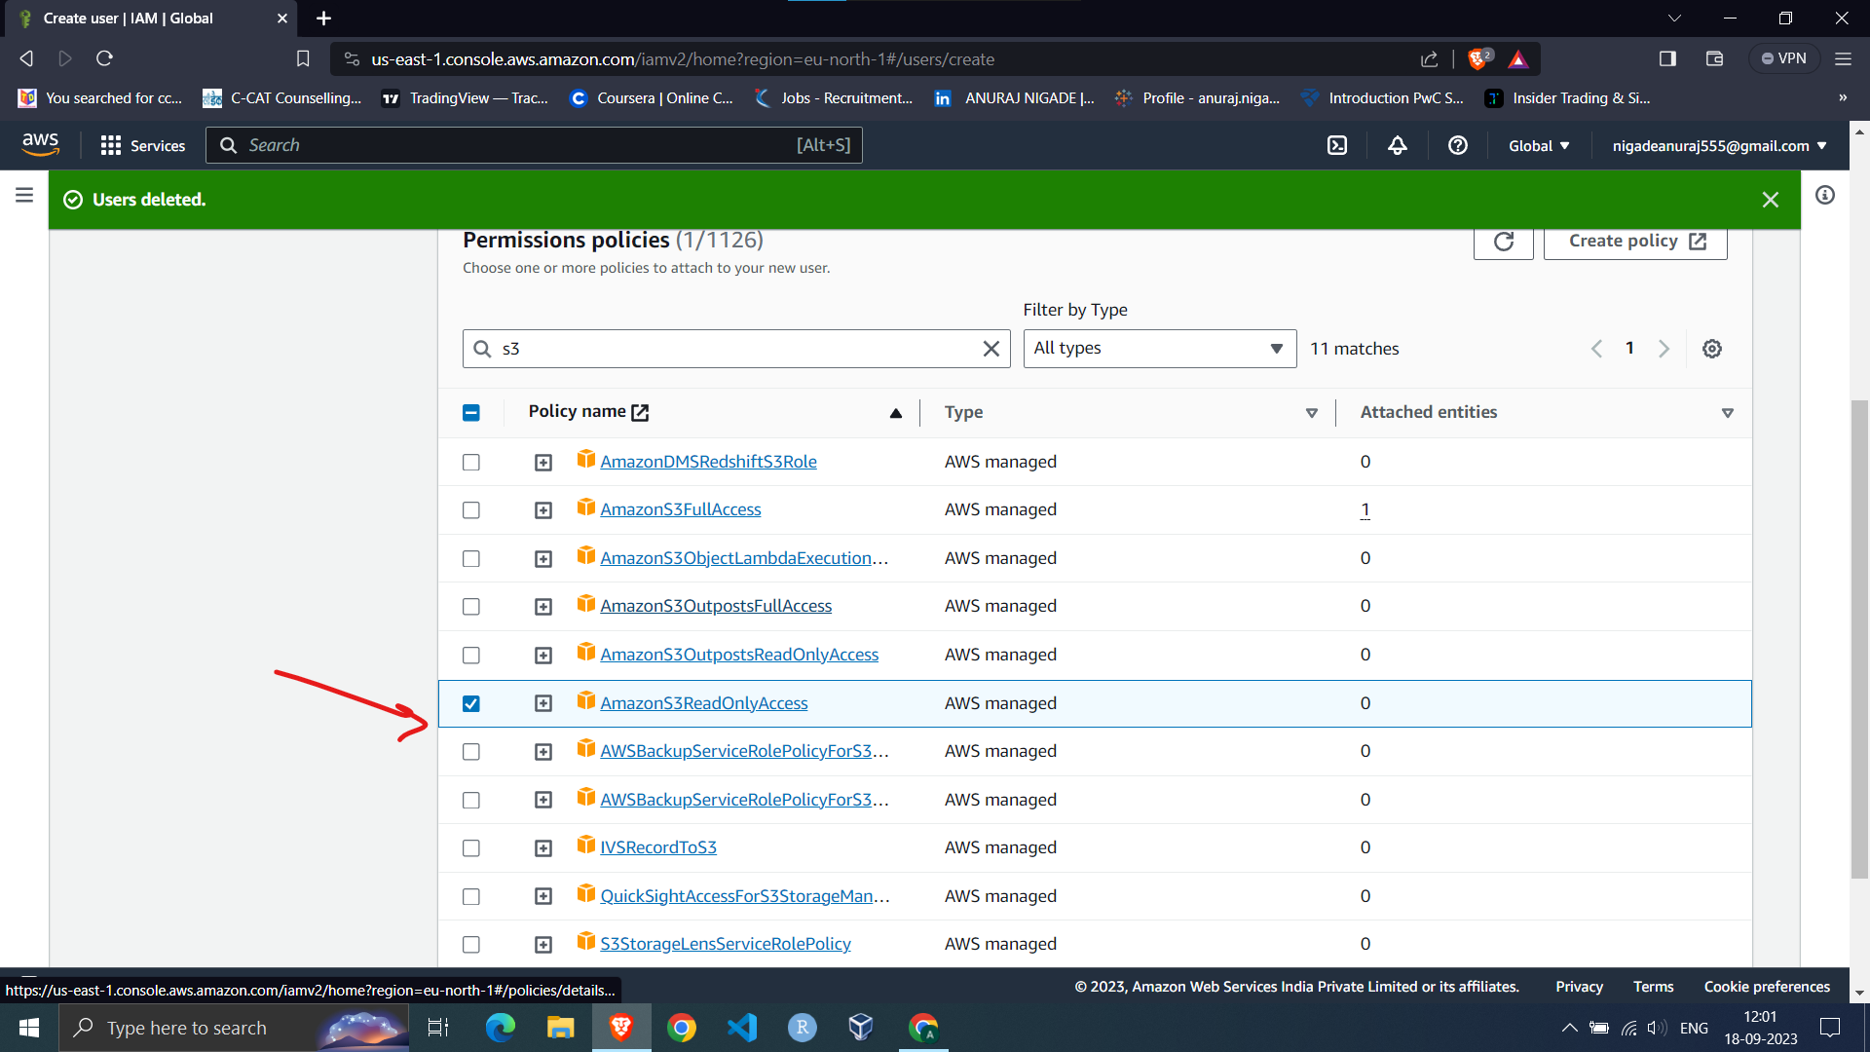

5)Then on next page click on create user to create that user

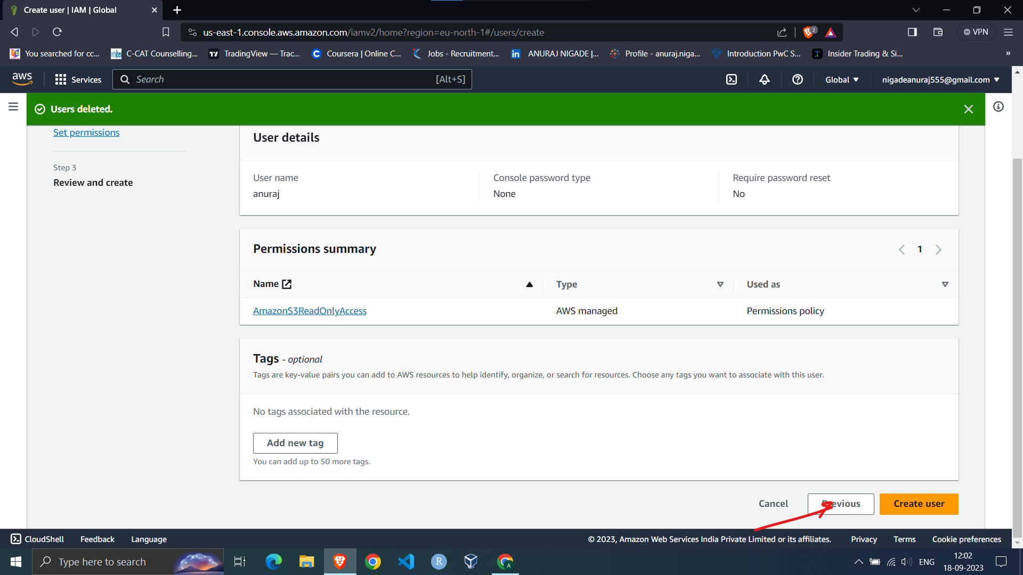

6)Now click on user username

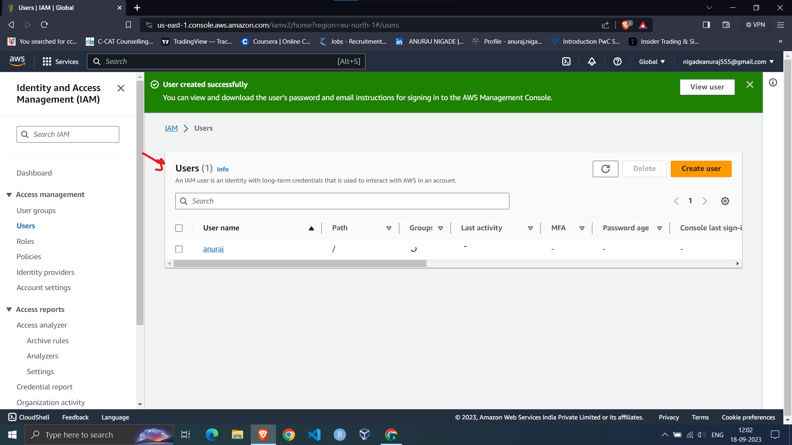

7)Then in permissions section you can check which permissions are given to user

